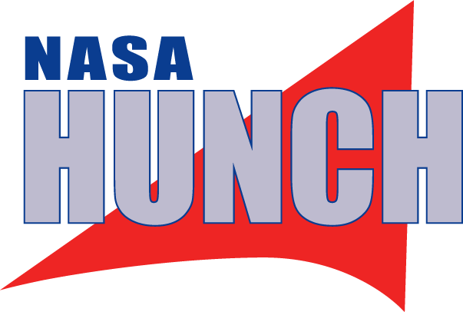
ACTE/NASA HUNCH Video Challenge Study Guide for Teachers and Mentors
The goals:
- Understand the Purpose of the video challenge for ACTE and NASA HUNCH

ACTE, empowers educators to deliver high-quality CTE programs that ensure students are positioned for career success. The video challenge’s purpose for ACTE is to offer students the opportunity to showcase the application of CTE and project-based learning programs in high-demand 21st century career fields on Earth as well as in space.

HUNCH stands for High School Students United with NASA to Create Hardware and is looking to extend its message of inspiring students through project-based learning to CTE students across the nation. NASA HUNCH’s video challenge offers students the opportunity to promote NASA and its missions through inspiring, creative, and educational videos for their peers.

Understand the Goal of the video challenge

- Inspire and educate students of all ages by sparking their imagination and creativity as well as broadening their own knowledge about NASA’s missions and the CTE careers.
- The audience for the videos is the peers of students making the videos. The videos should inspire and educate those watching the videos about NASA’s missions and the CTE careers needed to fulfill these missions.

- Understanding the current Theme of the Video Challenge

- Research the theme which changes for each school year for the 2023-2024 the theme is Why Go To The Moon?

- Understanding the rules of the video challenge

The contest is open to students of all ages, including elementary, middle school, high school and post-secondary students in any school or home schooler. Students may enter as individuals or as a team. There can be as many teams as a school wants to submit. However, students can only submit one video per year.
- Deadline to submit your video is April 1 at 11:59 p.m. EST 2024.
- Video entries must be 2 minutes or less in length
- Entries must include the CTE Month and NASA HUNCH logos.
- Entries must incorporate the following message, presented as text on-screen and/or spoken by talent: “Learn more about career and technical education at ctemonth.org and NASA HUNCH at nasahunch.com.”
- Videos can be presented in students’ language of choice. However, if not in English, please include readable subtitles.
- To finalize a submission, email the YouTube link to videochallenge@acteonline.org and
- Please provide the following with a YouTube link that can be uploaded to the ACTE and NASA
HUNCH YouTube playlist.
- School Name and address and
- Teachers’ contact phone number, email and mailing address
  - Students’ phone number, emails, and mailing address. If students win the award, we might need to contact them to mail awards.
- Entries that contain music or other copyrighted media must be accompanied by proof that entrants have the expressed permission of the original copyright holder. The following are examples of appropriate proof:
  - The name of the song along with the receipt from the school’s purchase of the song
  - A link to the website or YouTube video featuring the song
  - A signed letter or form stating that the music was created by a student in Garage Band or another program and that the student has been given permission for the music to be used royalty free
Please note: ACTE and NASA HUNCH retain the copyright on any submitted material and reserve the right to use the material in any way or format they see fit. Entries cannot be used for any commercial activity.

This year’s rules and regulations can be found at ACTE link at https://www.acteonline.org/why-cte/cte-awareness/cte-month/cte-month-2023-and-nasa-hunch-video-challenge/
And https://nasahunch.com/programs/video-and-media
The above links are not updated for the 2023-2024 competition yet.

- Understanding the Awards for the video challenge
ACTE and NASA HUNCH will announce by May 16, 2024, three winners, including one winner in each of the following grade levels. K-8, high school, and post-secondary. Student videos should strive to be creative, inspiring, and educational. The audience is students in all grade levels.
- NASA HUNCH will award the winning schools flown HUNCH patches (flown on the International Space Station!) mounted on framed plaques
- ACTE will award the winning schools $200 each, and each winning team member (maximum of 6 students per team) a $25 Amazon.com gift card.
- Winning videos and their Videos must be a minimum video resolution of 1280 x 720 format, or an audio independent format (e.g., Instagram square composition).
- Schools will be: Publicized on ACTE’s CTE Month webpage, in ACTE News, in Techniques magazine, via ACTE’s social media channels and in other ACTE’s communication channels.
- NASA HUNCH will share the videos at recognition Ceremonies, and on their YouTube website at winning videos

- Understanding the resources for the video challenge
We also have two amazing videos produced by a NASA Video Producer at JSC and a past HUNCH Student. The links for these videos are at https://www.youtube.com/watch?v=TKfKcJNUvds&list=PL3t8hjfINetbh_I3C22Q6SA8WchUQx8fe&index=2 and https://www.youtube.com/watch?v=SoC10kNPhOU&list=PL3t8hjfINetbh_I3C22Q6SA8WchUQx8fe&index=1 .

The following links have hundreds of NASA resources and videos that you’re welcome to use the footage from:
- NASA Johnson Space Center Video Imagery Update
- NASA Johnson Space Center Public Affairs Office Video Collection
- We also encourage you to view the collection of winning videos from previous years.
- The link is at at https://www.acteonline.org/why-cte/cte-awareness/cte-month/cte-month-nasa-hunch-winners/
- Most of the videos submitted last year are on the NASA HUNCH YouTube playlist at https://www.youtube.com/playlist?list=PL3t8hjfINetYY_BevQckrPfptYw6Phv6r
- Videos and images online that are NASA.gov are available for use in your videos.

- Understanding Rubric for judging

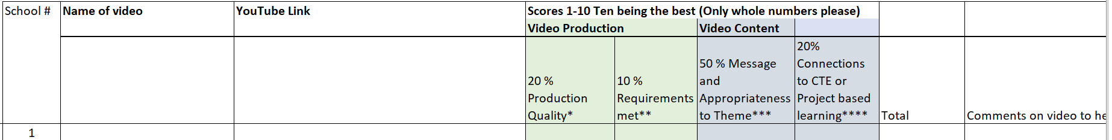
See attached rubric
- Understanding basics of video production
- How to develop a story board after doing research on the year’s theme
- Knowledge of what is legal to use on YouTube
- Understanding the importance of voice and pictures in enhancing each other
- Being able to be creative with animation and special effects

For more information visit the ACTE/HUNCH video challenge webpage here. For further questions about submissions, please contact Julia Kendrick at jkendrick@acteonline.org or 703-683-9377, or Florence Gold, Ed.D. at florence.v.gold@nasa.gov or 406-690-2661.
THANK YOU so much for YOUR Valued Participation

